Innovative matrix materials for molten carbonate fuel cells

Jhih-Yu Tang, Kuan-Zong Fung
Department of Materials Science and Engineering, National Cheng Kung University

Abstract
There are two ways to fabricate the dual conductive composite electrolyte as matrix for Molten Carbonate Fuel Cell (MCFC). Frist is infiltrating method. Fabricate a porous matrix which material is used samarium doped ceria (Sm_{0.2}Ce_{0.8}O₂ ; SDC). The porous matrix is infiltrated in molten carbonate (LiNaCO₃), and we can obtain the composite electrolyte. The second is mechanical-mixing method. The SDC powder and carbonate salt(Li₂CO₃ and Na₂CO₃) are mixed. Then, press a green disk and sinter. Two ways of fabrication are dual conductive composite electrolyte, and it helps to increase the performance of MCFC. According to the experiment result, in the infiltrating method, the volume ratio of SDC/carbonate is 49 : 51. In the mechanical-mixing, the volume ratio of SDC/carbonate is 43 : 57. By AC impedance measurement, the conductivity of sample by infiltrating method is 0.22 S/cm at 600ºC. The conductivity of sample by mechanical-mixing method is lower which is 0.107 S/cm at 600ºC. However, the performance is better than traditional electrolyte support (LiAlO₂) whether infiltrating method or mechanical-mixing method. In such a composite double conductive behavior will provide better conductivity through the fuel cell if parallel to CO₃²⁻ conductance, O²⁻ conductivity will manifest. This will result in an improvement in the performance of the MCFC, especially, increasing the ionic conductivity by additional O²⁻ conduction.

Keywords: MCFC、ceria、composite electrolyte、dual phase

一、Introduction
Fuel cells operating at elevated temperatures are suitable for medium and large scale applications, thus they have good prospects for commercialization, Molten Carbonate Fuel Cells (MCFCs) appear among the most promising in this respect. MCFC has a number of advantages over other high-temperature fuel cells
- high energy efficiency and high electromotive force [1],
(ii) Nickel instead platinum as a catalyst,
- electrolyte thickness of about 1 mm is much easier to manufacture,
- it can be used as a CO₂ separator due to its ability to capture carbon dioxide from the cathode side
LiAlO₂ is a very effective support for molten carbonate, however, there is a limited number of manufacturers, and so, it makes it very expensive. In a single conducting electrolyte, the cathode inlet needs to contain an adequate ratio of CO₂ to O₂, (2:1), this results in a low oxygen partial pressure at the cathode inlet (taking into account that oxygen is being delivered in air at an initial molar fraction of 21%). The low pressure of oxygen results in a relatively low Nernst voltage, and finally decreases the MCFC performance [2, 3]. By using a dual conducting electrolyte [4], it is possible to obtain a more favorable ratio between carbon dioxide and oxygen (CO₂ :O₂ ).
Matrix layer, which using a less expensive material, is the most important problem to be solved for the wide implementation of MCFCs. It was found, that ceria–based composite is a good oxygen ion conductor used in SOFC applications [5]. It can be expected, that the application of ceria–based porous layers as the MCFC matrix would improve its performance in a less expensive way. The vast majority of electrochemical ceria– based electrolyte support testing was conducted using a very thin matrix layer. This does not correctly reflect the conditions prevailing in the MCFC, where carbonate ions play a decisive role in the transport of reactants and charge carriers. In the present project where a ceria–based porous layer is used as a molten carbonate electrolyte support, this will be tested in a fuel cell on a systematic basis. Existing data is mainly for the short term oxygen ion conductivity of a ceria–based support. In the current project, we will conduct systematic tests of dual ion conductivity and long– term stability in MCFC conditions.

二、Experimental
2.1 Powder synthesis:
SDC (samarium doped ceria, Sm_{0.2}Ce_{0.8}O₂) is synthesized by co-precipitation. Starting materials Ce(NO₃)₃·6H₂O and Sm(NO₃)₃·6H₂O in a stoichiometric ratio were first mixed with deionized water. Once the nitrates are completely dissolved, the nitrates solution was added into the oxalate acid solution. The PH of oxalate acid solution is 6.5 by adding ammonia before the nitrates solution adds into oxalate acid. After mixing, the precursor is precipitated. Use deionized water and ethanol washing several times and dry it. The SDC precursor is calcined at 750ºC, then, get the pure SDC. The preparation of Li/NaCO₃ binary eutectic salt is by ball milling, and heat binary eutectic salt at 650ºC to make sure Li₂CO₃ and Na₂CO₃ mixing homogeneously.

2.2 Fabrication process of composite electrolyte:
There are two way to fabricate the composite electrolyte. First is infiltrating method. SDC mixes with starch and ethanol. Starch is as pore former. The mixture is milled by Zirconium ball for a day, then, dries it at 90ºC. Press the SDC/starch green disk and sintering at 1300ºC for 2 hours. After sintering, the porous SDC matrix put in molten carbonate (LiNaCO₃) at 650ºC for one hour.
The second is mechanical-mixing method. SDC and LiNaCO₃ are mixed with a weight ratio of 3:7by ball milling. The mixture is calcined at 650ºC for one hour. The powder of calcined SDC/carbonate is pressed into the green disk, and sintering at 650 ºC in air for one hour to form composite electrolyte.

三、Results and Discussion
Fig.1 was showed the XRD patterns of SDC powder prepared by co-precipitation after calcined with LiNaCO₃, The result suggests that there is two diffraction pattern which belongs to SDC and LiNaCO₃ powder. It means there is no chemical reaction between SDC and LiNaCO₃, the SDC is stable in the molten carbonate and suitable sever as a electrolyte substrate for MCFC application.

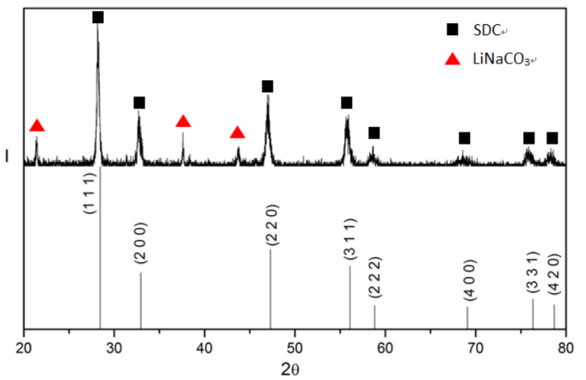
Fig.1 The XRD trace of SDC powders obtained by co-precipitation after calcined with carbonate

The SEM micrographs of the SDC porous matrix were showed in Fig.2. By using different fraction of pore former, the matrixes have different porosity. The Alvani et al. [6] are suggesting that the porosity of matrix in MCFC should more than 50%. In this study, the porosity of matrix is about 53%, it also indicating that the enough molten carbonate can infiltrate into the matrix and to form a composite electrolyte. However, the pore size of our study is about 10 µm which is also means the overflows of molten carbonate from the matrix may happen after a long working time.
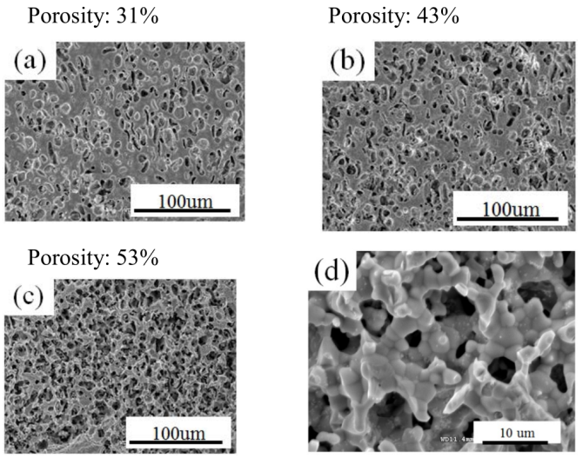
Fig.2 The SEM images with various porosity are showed in the figures respectively. The figure (a) (b) (c) are the cross section images, and (d) is zooming in from (c).

Fig.3 showed the ionic conductivity of the composite electrolyte SDC-LiNaCO₃ fabricated by infiltrating method. The volume ratio of SDC/carbonate is 49 : 51. The conductivity of composite electrolyte was increase by increasing temperature, after temperature more than 450ºC, there is significant enhancement of conductivity, which is suggested the melting of carbonate. After temperature reach to 600ºC, the conductivity of composite electrolyte is 0.22 S/cm which is 10 time high of the tradition LiAlO₂ matrix at 600ºC (the ion conductivity is 0.028S/cm) [7].
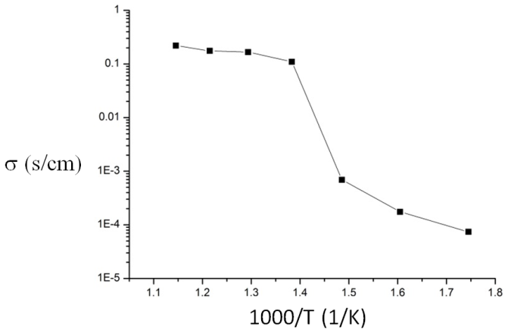
Fig.3 The AC impedance measurement of composite electrolyte by infiltrating method

For mechanical-mixing method, the sample is prepared with a cost-effective, co-pressing and co-sintering technique. The volume ratio of SDC/carbonate is 43 : 57. The conductivity of SDC composite electrolytes by mechanical-mixing obtained from AC impedance analysis was showed in Fig. 4. The result of composite electrolyte at 400~450ºC has obviously increasing slope due to the melting of carbonate. The phenomenon is the same as infiltrating method. However, the conductivity is about 0.107S/cm at 600℃. Compare with these two methods, the infiltrating method was showed the better performance due to the better connection between the SDC and carbonate powders.
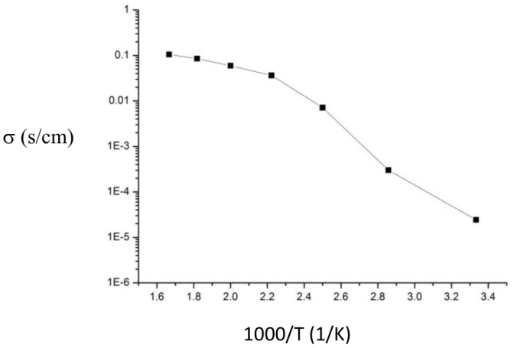
Fig.4 The AC impedance measurement of composite electrolyte by mechanical-mixing method

The ion conduction mechanism is shown in Fig. 5. [8] The interface in composite electrolyte supplies high conductive path for proton, while oxygen ions are probably transported by the SDC grain interiors. It is proposed an empirical “Swing Model” to interpret the superior proton conduction. When protons approach the composite electrolyte from anode, it can form meta-stable hydrogen bonds with oxygen ions from both SDC surface and CO₃²⁻ group. When the operating temperature is above the glass transition temperature of amorphous carbonate phase, the bending and stretching vibration of C-O bonds are enhanced, as well as the mobility and rotation of CO₃²⁻ group. These enhanced movements facilitate rapid breaking and forming of hydrogen bonds in the interface region, leading to effective long-range proton transportation driven by proton concentration gradient. In this process, carbonate serves as a “bridge” for protons to move from one hydrogen bond to another.
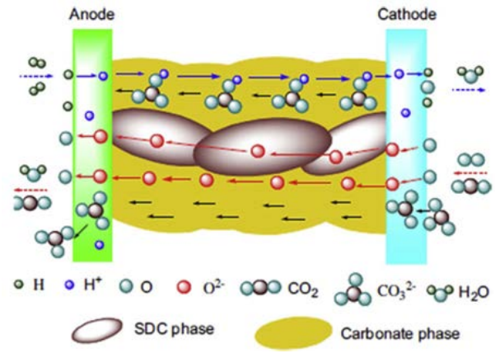
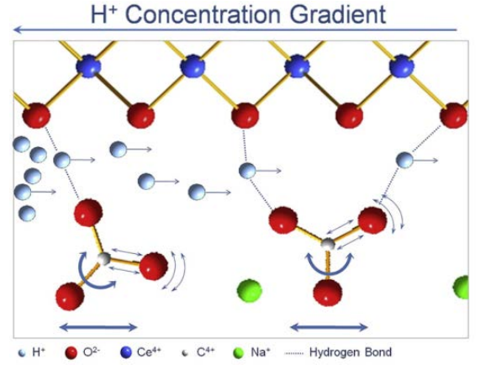
Fig.5 Ionic conduction pathway for oxygen ions, proton and carbonate ions when the cathode gas is the O₂ and CO₂ mixture

四、Conclusion
SDC syntheses successfully by co-precipitation. After calcining with LiNaCO₃ , the SDC powder still
show the characteristics of the cubic fluorite phase. There is no chemical reaction between SDC and molten carbonate. In our research, the highest porosity of matrix is 53%. However, the pore size is about 10 micrometer. It is too large for porous matrix in MCFC. The carbonate could be overflow for long working time. The ion conductivity of SDC-LiNaCO₃ composite electrolyte by infiltrating is 0.22S/cm, which is higher than mechanical-mixing method (0.107S/cm). But, by mechanical-mixing method, it is prepared with low temperature heat treatment and low cost. Above the glass transition temperature of amorphous carbonate phase, the interface the interface in composite electrolyte supplies high conductive path for proton while oxygen ions are probably transported by the SDC grain interiors.

參考文獻
[1] J. Milewski, M. Wołowicz, A. Miller, and R. Bernat: A reduced order model of Molten Carbonate Fuel Cell: A proposal, International Journal of Hydrogen Energy 38(26), 11565–11575, 2013.
[2] J. Milewski, and A. Miller: Optimization of the Working Conditions of a Single Molten Carbonate Fuel Cell, Applied Mechanics and Materials 267, 64–71, 2013.
[3] J. Milewski, M. Wołowicz, and J. Lewandowski: Optimization of the Working Conditions of a Laboratory Size (100 cm2) Molten Carbonate Fuel Cell, ECS Transactions 51(1), 37–45, 2013.
[4] J. Milewski, W. Bujalski, M. Wołowicz, K.Futyma, J. Kucowski, and R. Bernat: Determination of Electronic Conductance of 100 cm2 Single Molten Carbonate Fuel Cell, Applied Mechanics and Materials 346, 23–28, 2013.
[5] L. Fan, C. Wang, J. Di, M. Chen, J. Zheng, and B. Zhu: Study of ceria carbonate nanocomposite electrolytes for low-temperature solid oxide fuel cells, Journal of nanoscience and nanotechnology 12(6), 4941–4945, 2012.
[6] C. Alvani, E. Roncari, Preparation and characterization of γ-LiAlO 2 tiles for the molten carbonate fuel cells, High Temperatures–High Pressures 20 (1988) 247–250.
[7] H. Nafe, Conductivity of Alkali Carbonates, Carbonate-Based Composite Electrolytes and IT-SOFCECS, ECS Journal of Solid State Science and Technology, 3 (2) N7-N14, 2014
[8] Y. Zhao, C. Xia, Y. Wang, Z. Xu, Y. Li, Quantifying multi-ionic conduction through doped ceria-carbonate composite electrolyte by a current-interruption technique and product analysis, International Journal of Hydrogen Energy, Volume 37 Issue 10 8556–8561 May 2012

雙傳導複合電解質於燃料電池之研究

湯智羽, 方冠榮
國立成功大學 材料科學及工程研究所

摘 要
製備熔融碳酸鹽燃料電池之複合電解質層有兩種技術，一種是滲透法，先製備多孔隙率之氧化鈰參雜氧化釤(Sm_{0.2}Ce_{0.8}O₂ ; SDC )之電解質基材，並滲入熔融態鋰鈉碳酸鹽 (LiNaCO₃)，使形成熔融碳酸鹽燃料電池(Molten Carbonate Fuel Cells ; MCFC)之複合電解質層，另一種是機械混合法，將參雜氧化鈰之粉末先直接與碳酸鹽做混合，再壓錠成型做燒結，兩種技術都是以雙重離子導性之電解質，進一步提升熔融碳酸鹽燃料電池之效能，實驗結果顯示在滲透法中多孔氧傳輸基材(SDC)與鋰鈉碳酸鹽體積比為49:51，而機械混合法氧傳輸基材與鋰鈉碳酸鹽體積比為43:57，經由交流阻抗測試，其滲透法複合電解質層之導電率在600ºC最高可到0.22 S/cm，而機械混合法導電率略低，其導電率為0.105 S/cm，但不論何種技術，複合電解質層之導電率相較於傳統熔融碳酸鹽燃料電池之LiAlO₂電解質高50~100%之導電率，在複合雙重導電路徑，CO₃²⁻與O²⁻可以同時進行離子傳輸，使熔融碳酸鹽燃料電池可提供更佳的離子導電能力。

關鍵詞：熔融碳酸鹽燃料電池、氧化鈰、複合電解質層

